**Project Title:** Multi Arcade Game

**Developer:** Niall McCann

**Designer:** Raja Naseer Ahmed Khan

**Overview**

This project design involves making a 4 in 1 game which would consist of a main menu to choose your game of choice. From there you will be able to play your selected game.

Game 1: Pacman

Game 2: Pong

Game 3: Road Collector

Game 4: Space Invaders

**Development**

Through talking with Raja, and explaining the amount of work that is involved in the creation of 4 games, where the spec was to design 1, in the given time frame, we agreed that dropping one of the games was an understandable adjustment to the design document. From here I decided that the games I would attempt to develop would be: Pacman, Pong & Space Invaders. For these games, each are selected through the Main Menu, each game has its own unique background music, where each menu also has its own music.

**Main Menu**

For the development of the main menu, the game scene will show the user a background with a title of the 3 in 1. From here the user will see 3 buttons, each representing a different game, Pacman, Pong and Space Invaders. When the user clicks the selected game button, they will be brought to the desired game.

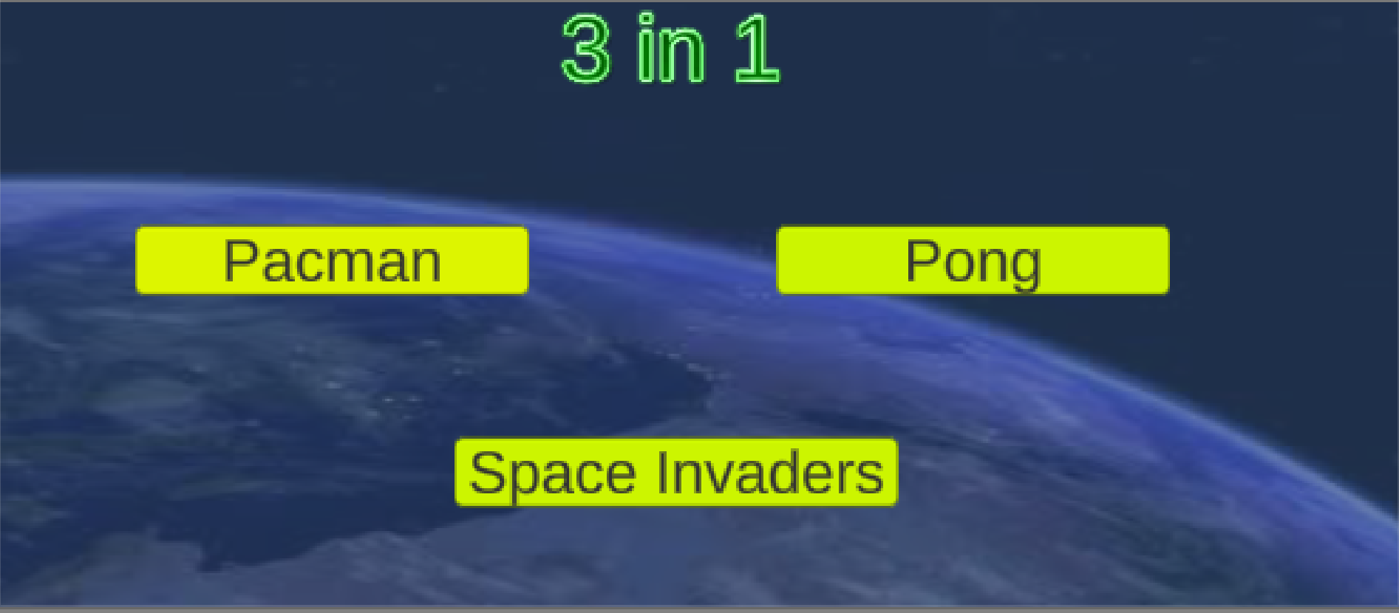

**Pause Menu**

In each game located in a corner, the user will be able to select the pause button. Once selected the user will be able to “Quit” the game, “Start” the game again, or else select “Options”, where they will be able to control the volume of the games. The volume is controlled by using a slider, which when brought to the right is at its loudest, and when brought completely to the left is the music on mute.



**Pacman**

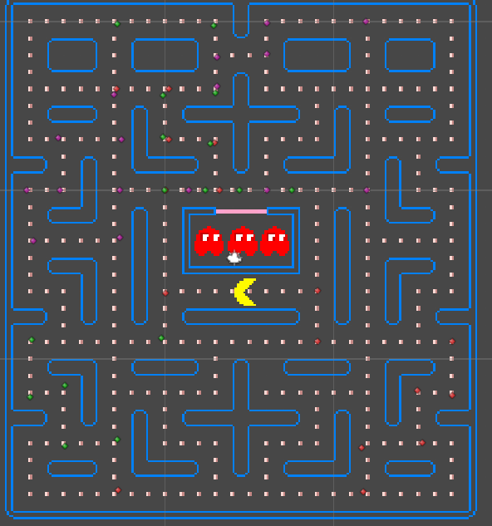I found developing this game very time consuming and challenging. Designing the map, adding separate colliders to each wall, and the placement of each individual pacdot. Also after searching through the web, I was only able to find a sprite sheet for Blinky( this is to change his figure depending on which direction he is travelling), not the rest of the ghosts, so after spending so much time on this, I decided to just continue with what I had to try and develop the game within the timeframe, so I have three Blinky ghosts running throughout the level, following various paths by using waypoints to dictate their movement. Whilst using Pacman, the user is able to move him in the desired direction, where he, like Blinky will change his animation depending on the button selected. While Pacman runs through the level he will be running over the pacdots, which as he collides with them they will disappear. If one of the ghost should collide with Pacman, his gameObject will be destroyed and the user will then be prompted to end the game and select the menu to restart.

**Pong**

During development of this game, I found it to be very interesting, as having grown up with an older brother, this was one of the big games in our house growing up. For the Pong game, the user will be able to select the game from the main menu, where the user will then begin the game. The ball will not start moving until 5 seconds after the game has begun, or each time the ball respawns. The ball will start by heading in a different random direction after each respawn. From here the users can control each paddle by using inputs from the keyboard. For the left paddle the “W” and “S” characters will control the up and down movement of the paddle, and for the right paddle, the up and down arrow keys will control the up and down movement here. The top and bottom of the game are enclosed in colliders, so that the ball, and players cannot move their pieces outside this range. If the ball should hit off the top or bottom of the screen, it will be returned with the same speed, and at an angle opposite to entry. If the ball should pass by either of the players, the ball will respawn in the centre of the screen to play again. Also once the ball goes behind a paddle, the player who scored, will receive a point.

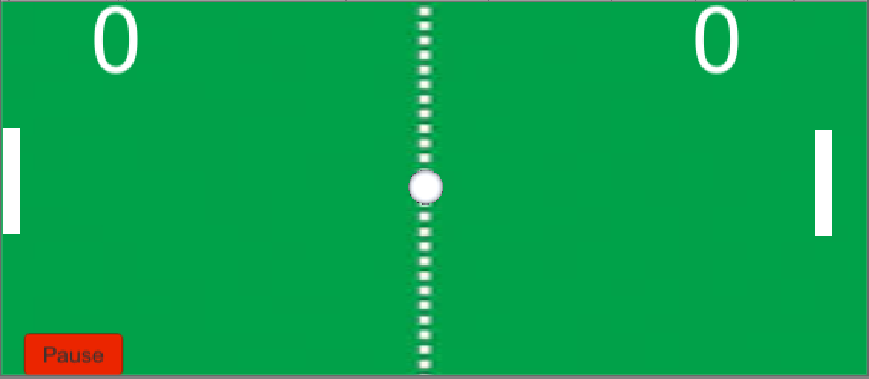

**Space Invaders**

I enjoyed the development of this game, as it truly is a classic. For Space Invaders, again the user can choose the game from the Main Menu. Once the game is selected the enemies will start to move across and down the screen. They will shoot random bullets at the user, where the user will attempt to avoid these bullets and hide under the cover blocks. The user can be moved by using the arrow keys on the screen, and for the user to fire, they must simply flick their fingers on the touchpad of the laptop. This will fire bullets, but not continuously, only as prompted to make the game more difficult. Developing this game was more challenging, as I did not receive any sprites, so I decided to create each of the enemies and the player from different space and colours in Unity.

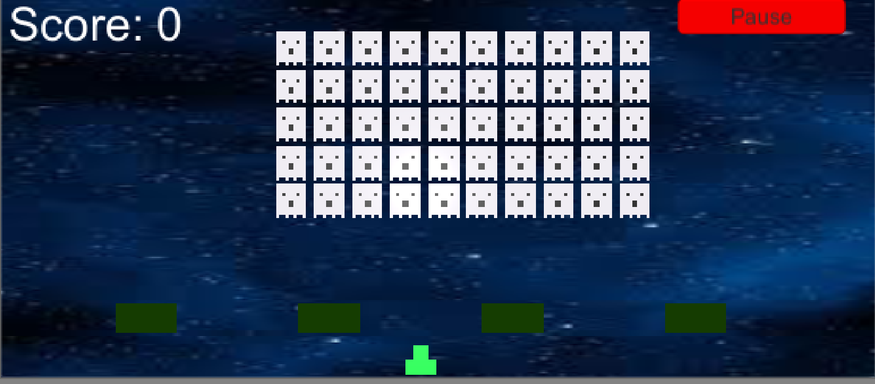

**Test Plans**

These are the test plans based on the Design Document from Raja

* Run on Android - Complete
* Run on Windows 10 - Complete
* Check if each game is loading by the buttons - Complete
* Check if play/exit button are working - Complete
* If multiplayer added for game – Working locally for pong, not on server.

**References**

<http://noobtuts.com/unity/2d-pacman-game?fbclid=lwAR3b2b-F1kg71JYyPT42p2-bKZEPghUYaaKwAasPmzhHJbJbOfQJOjKJpS>

<https://www.sitepoint.com/adding-pause-main-menu-and-game-over-screens-in-unity/>

<https://www.youtube.com/watch?v=QZDw8ycoLRw>

<https://www.youtube.com/watch?v=1TULw0ozlK0>

<https://www.youtube.com/watch?v=ZLp3bl45avE>

<https://www.youtube.com/watch?v=IgZQjGyB9zg>

<https://downloads.khinsider.com/game-soundtracks/album/legend-of-zelda-the-twilight-princess-hd-original-soundtrack>

<https://www.youtube.com/watch?v=KoFDDp5W5p0>